

RocketCX

Contact Flow Deployment Guide

# Document Control

1.1 Details of Authorship

|  |  |
| --- | --- |
| Name(s)  Title(s)  Organisation | Ashpak Mulani  Senior Consultant, Cloud  ECS |

1.2 Version Control

|  |  |  |  |
| --- | --- | --- | --- |
| **Version** | **Date** | **Author** | **Changes & Reason for Change** |
| 1.0 | 27/11/2019 | Ashpak Mulani | First Draft |
| 1.0 | 06/12/2019 | Arthur Hendric | Review and update first draft. |
|  |  |  |  |
|  |  |  |  |
|  |  |  |  |
|  |  |  |  |
|  |  |  |  |
|  |  |  |  |

1.3 Distribution

Please enter the names of document recipients required for final version. Sign-off is only required when Version Control above indicates Final Version for Sign-off.

|  |  |  |  |  |
| --- | --- | --- | --- | --- |
| **Document Recipients** | **Version** | **Sign off** | **Signature** | **Date** |
|  |  |  |  |  |
|  |  |  |  |  |
|  |  |  |  |  |

Contents

1. Document Control 1

1.1 Details of Authorship 1

1.2 Version Control 1

1.3 Distribution 2

2 Pre-requisites 4

3 Contact Flows 4

3.1 Import Contact Flows 4

3.2 Whitelist lambda functions 5

3.3 Publish Contact Flows 6

3.3.1 QuickStart-Demo-ActiveRecordsFlow 6

3.3.2 QuickStart-Demo-WelcomeFlow 7

3.4 Attach Phone number to Welcome Contact Flow 8

4 Contact flow overview 10

5 Testing Steps 11

# Pre-requisites

Before proceeding with the process of (state whatever the process is) ensure the following guides have been reviewed and the documented actions completed:

* RocketCX Application Installation and Configuration Guide (to set up RocketCX)
* RocketCX User Guide
* RocketCX Quick Start Guide (to establish demonstration Lambda functions)

# Contact Flows

This demo consists of two Contact Flows QuickStart-Demo-WelcomeFlow and QuickStart-Demo-ActiveRecordsFlow

## 3.1 Import Contact Flows

Log in to your Amazon Connect instance on the AWS console using an account with Admin privileges for the Amazon Connect service. Select Amazon Conenct instance where you want At this stage, we will NOT be publishing any contact flow. For now, we will only save and publish them in later stages.

Download [QuickStart-Demo-WelcomeFlow](https://rocketcx.s3.amazonaws.com/EnterpriseConnectorforServiceNow/v1/ContactFlows/Public/QuickStart-Demo-WelcomeFlow) and [QuickStart-Demo-ActiveRecordsFlow](https://rocketcx.s3.amazonaws.com/EnterpriseConnectorforServiceNow/v1/ContactFlows/Public/QuickStart-Demo-ActiveRecordsFlow) to start the process

1. Choose Routing 🡪 Contact flows 🡪 Create New contact flow

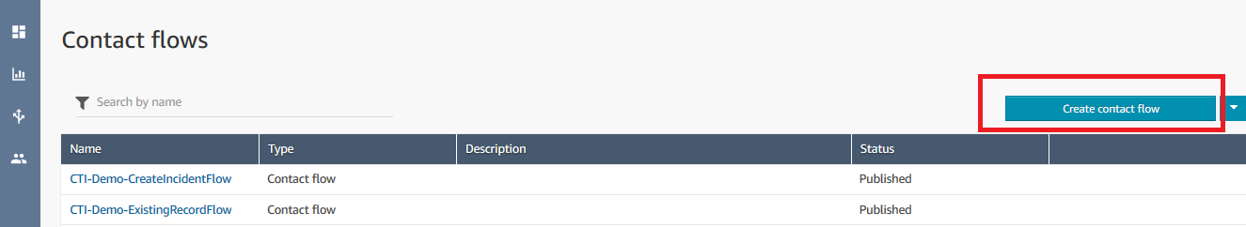

1. Choose Save (down arrow) 🡪 Import flow. Import and save both the downloaded contact flow

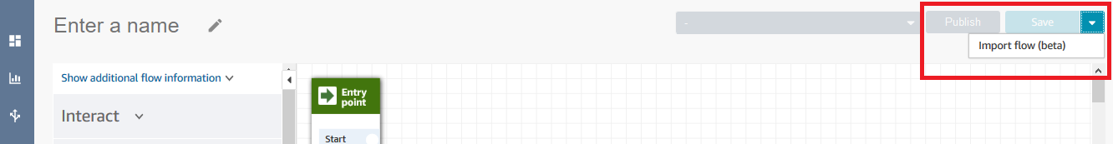

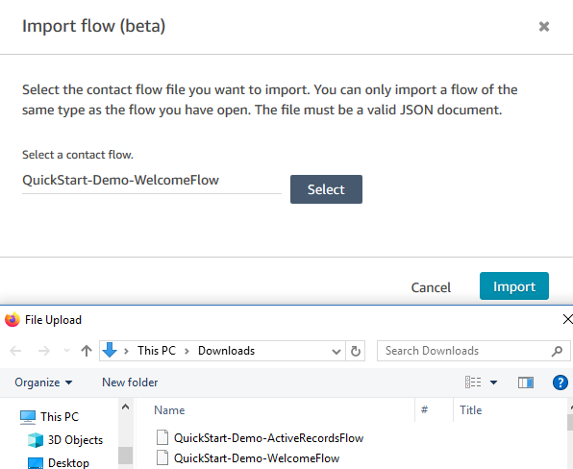

## 

## 3.2 Whitelist lambda functions

Open Amazon Connect instance and select the “Contact flows” option on home page.

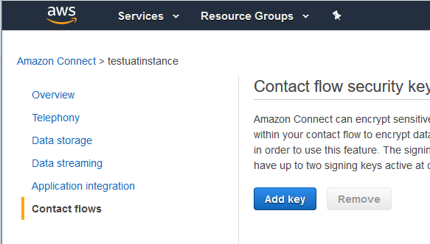

Move to AWS lambda section and add all four Lambda functions deployed using quick start.

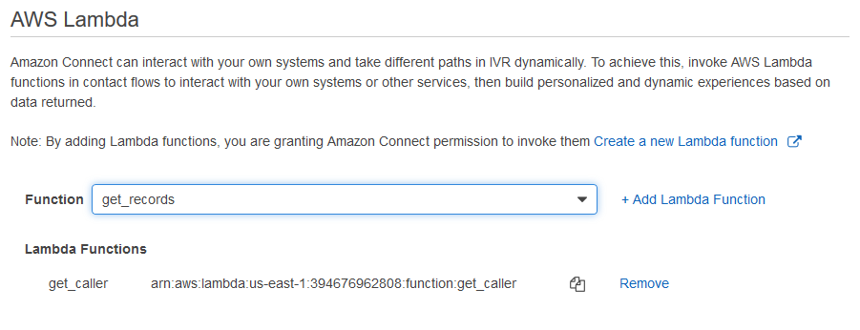

## 3.3 Publish Contact Flows

### 3.3.1 QuickStart-Demo-ActiveRecordsFlow

Open the Lambda function reference found at the beginning of the Contact Flows and select “get_records” function in the Function ARN field.

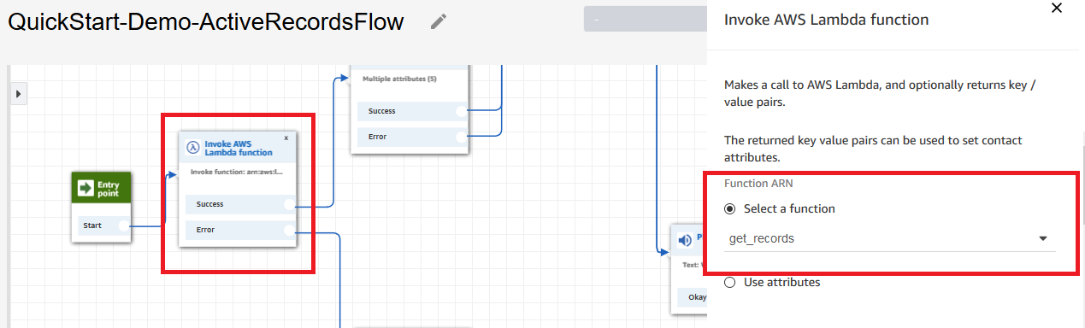

Open the Lambda function reference found after the store customer input box, and select the “search_record” function in the Function ARN field.

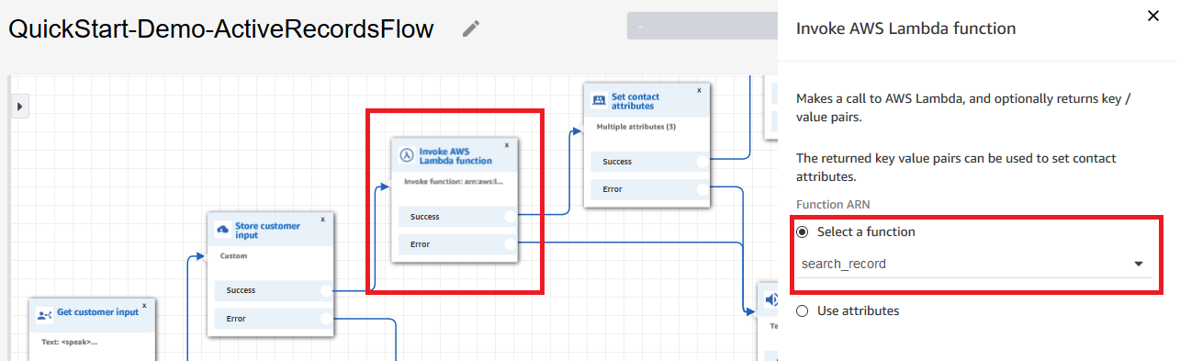

Save the changes made to the Contact Flow and click on “Publish”

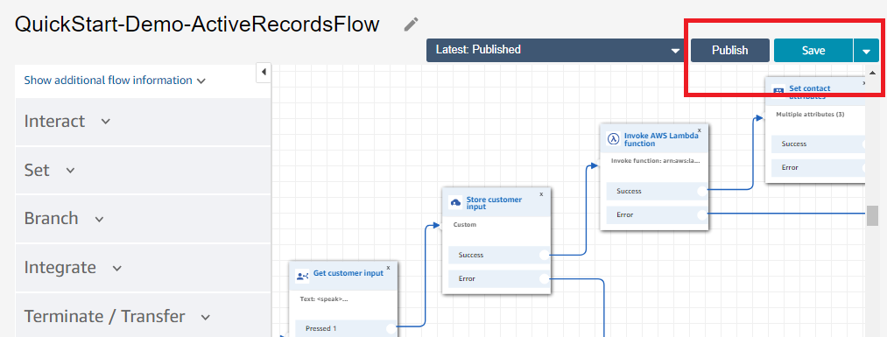

### 3.3.2 QuickStart-Demo-WelcomeFlow

Open the Lambda function reference found at the beginning of the Contact Flows and select “get_caller” function in Function ARN field.

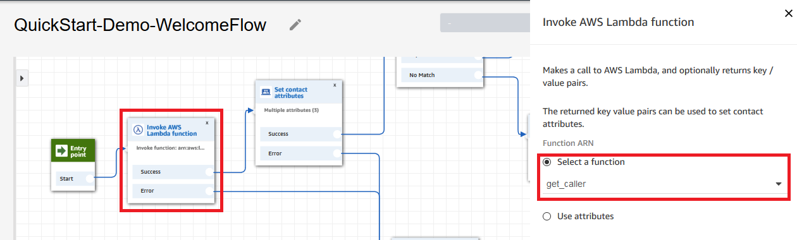

Open the “Transfer to flow” box, select “QuickStart-Demo-ActiveRecordsFlow”, and save the configuration.

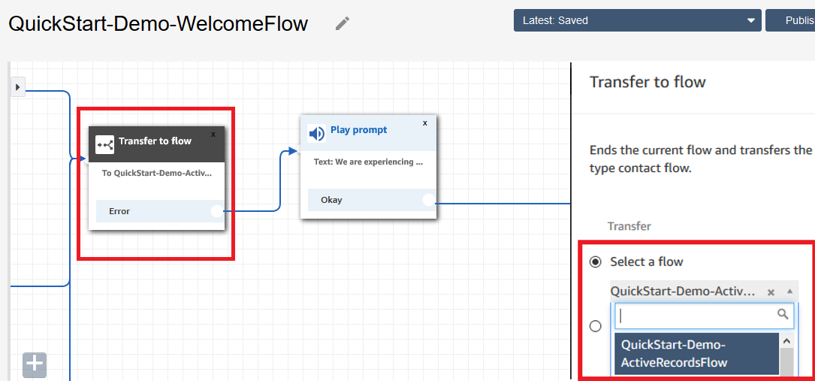

Save changes made to the Contact Flow and click on “Publish”

## 3.4 Attach Phone number to Welcome Contact Flow

Got to Routing 🡪 Phone numbers and click “Claim a number”

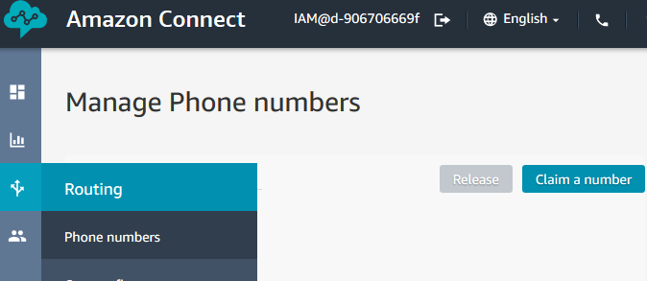

Select a Phone number and attach a Welcome Contact Flow to the selected phone number

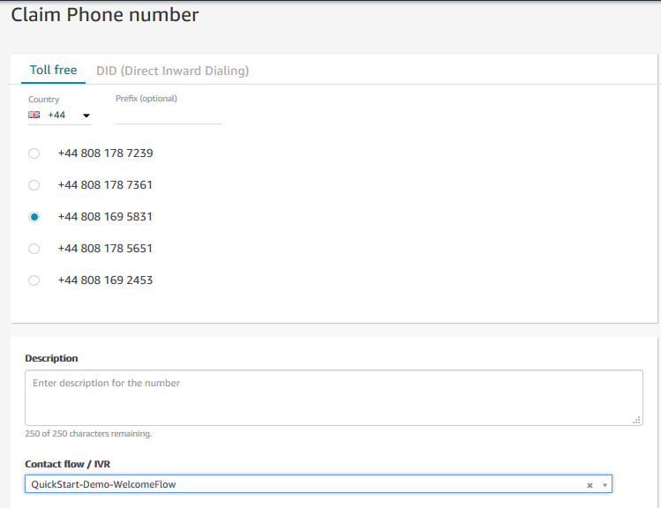

# Contact flow overview

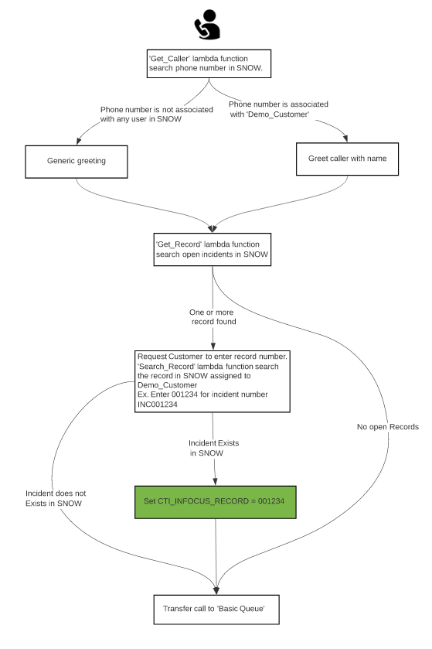

# Testing Steps

1. Create a User in Service Now with Name ‘Demo_Customer’ and update the phone number field with the phone number you will be using for testing.
2. Create one test incident and assign caller field to Demo_Customer.
3. Dial into Amazon Connect and select a path to enter a record number.
4. On request, enter record number assigned to Demo_Customer. Ex. For INC001234 enter 001234 using dial pad. In this step, Contact Flow will set a contact attribute with name CTI_INFOCUS_RECORD to entered record number (001234). Rocket CX CCP has designed to read value from this contact variable and perform a screen-pop.
5. RocketCX CCP should show incoming call for Agent logged into basic queue and show caller details with screen-pop for the entered record number.